|  |  |
| --- | --- |
| **EX.NO: 1** | **SETUP VIRTUAL SDN LAB USING MININET** |
| **DATE:** |

**AIM:**

To setup virtual SDN lab using mininet.

­­

**PROCEDURE:**

**Step 1: Install Mininet :**

Install the base Mininet package by entering the following command:

$ sudo apt-get install mininet

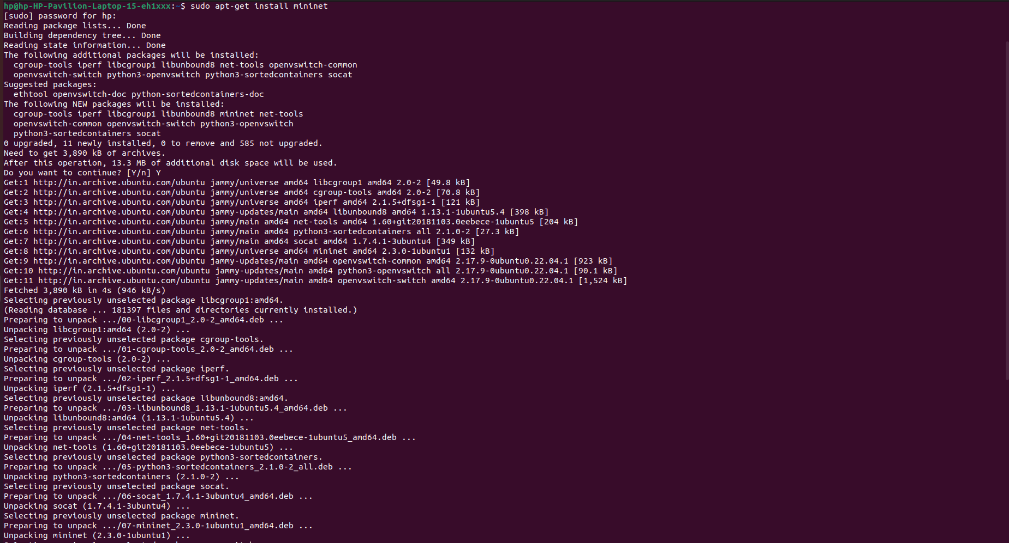

Check the version of mininet installed using the following command:

$ mn --version



Mininet supports multiple switches and OpenFlow controllers. For this test, we will use Open vSwitch in bridge/standalone mode. To test this, try:

$ sudo mn --switch ovsbr --test pingall

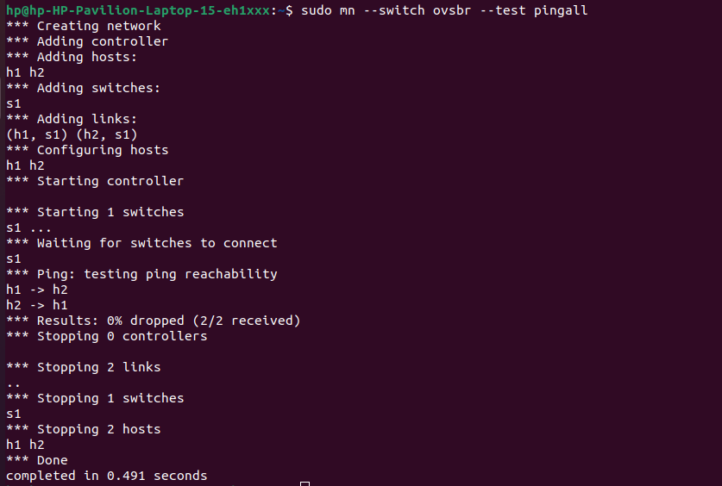

If Mininet complains that Open vSwitch isn’t working, make sure it is installed and running:

$ sudo apt-get install openvswitch-switch

$ sudo service openvswitch-switch start

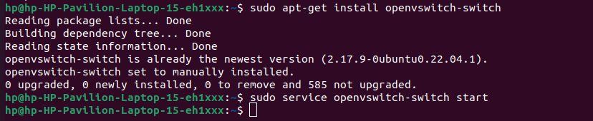

Once Mininet is installed, you can start it by running:

$ sudo mn

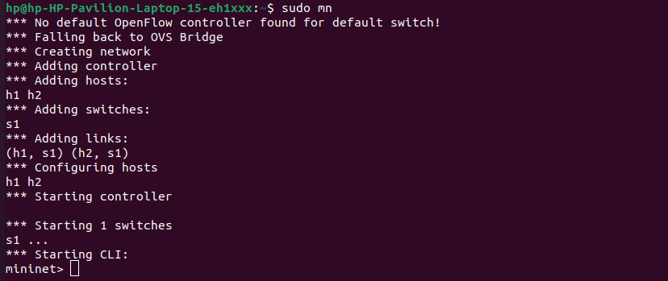

**Step 2 : Experiment with the Default Topology:**

We can experiment with the default Mininet topology by running commands inside the Mininet CLI.

$ mininet> pingall

$ mininet> h1 ifconfig -a

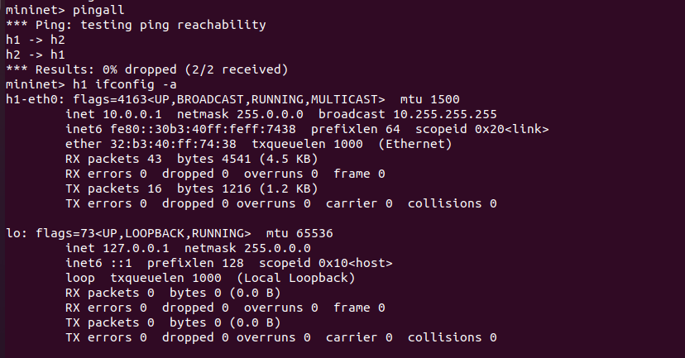

In order to ping host 1 from host 2, run the following command:

mininet> h1 ping h2

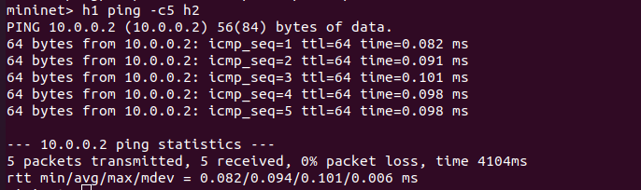

To create custom topologies with two switches and two hosts connected to each switch, run the following command.

$ sudo mn --custom myfirsttopo.py --topo myfirsttopo –controller=remote

//myfirsttopo.py

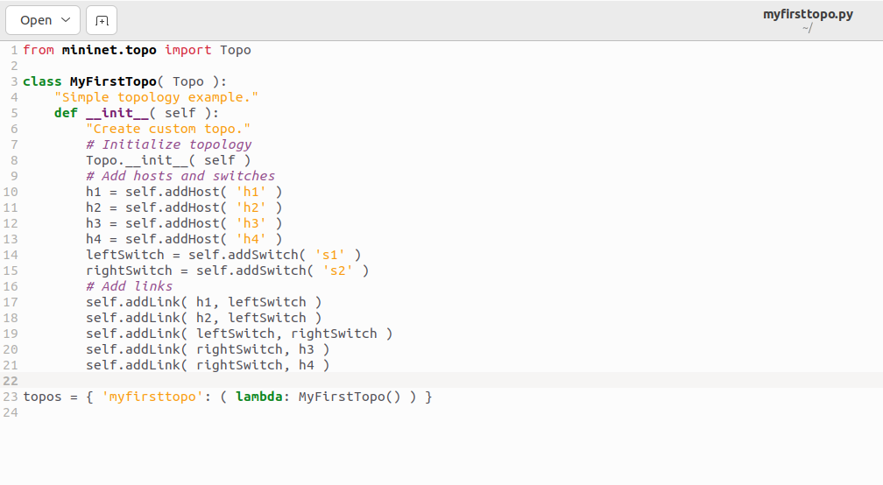

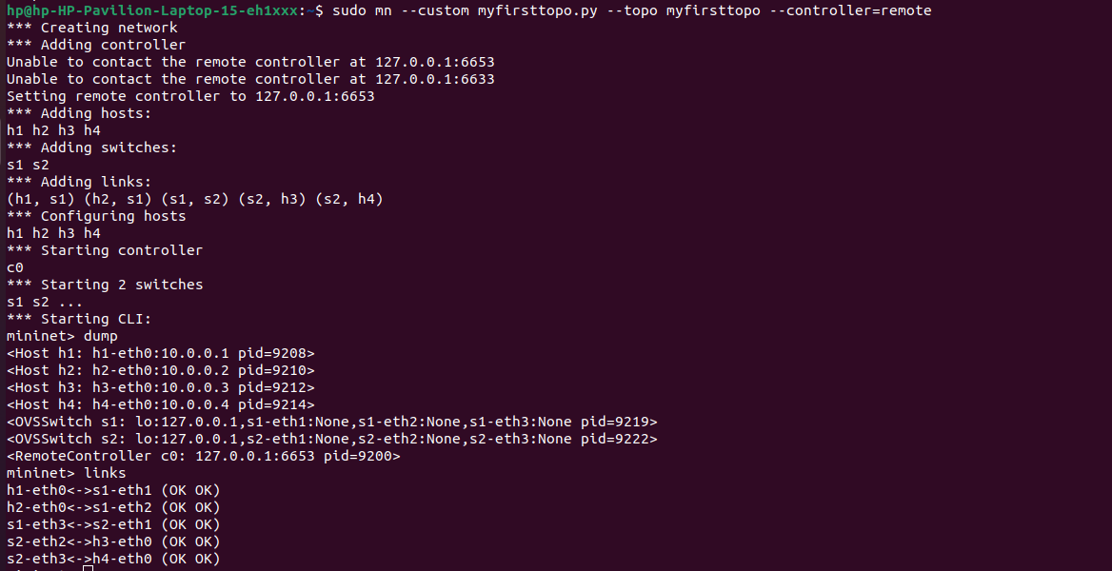

**OUTPUT:**

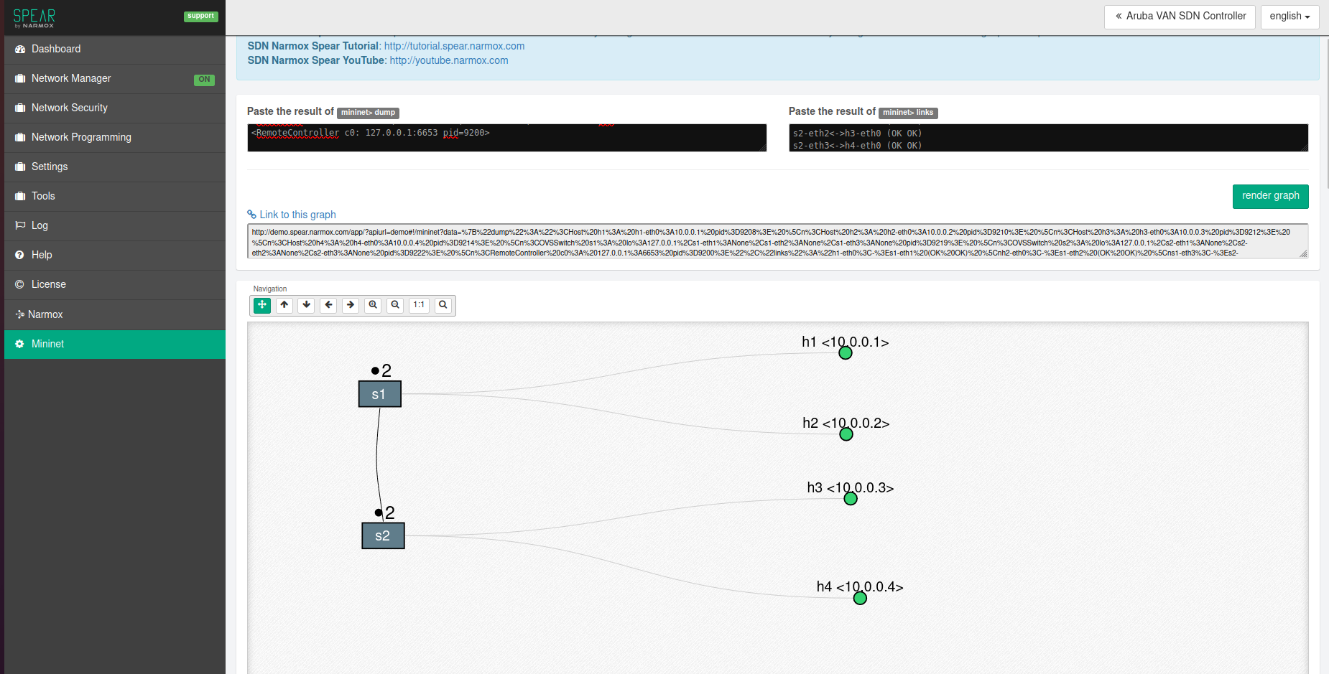

|  |  |  |
| --- | --- | --- |
| **Evaluation**  **Parameter** | **Max.**  **Marks** | **Marks**  **Awarded** |
| Observation | 20 |  |
| Implementation | 40 |  |
| Output | 10 |  |
| Viva | 10 |  |
| Record | 20 |  |
| **Total Marks** | **100** |  |

**RESULT:**

Thus a virtual SDN lab was successfully setup using mininet.